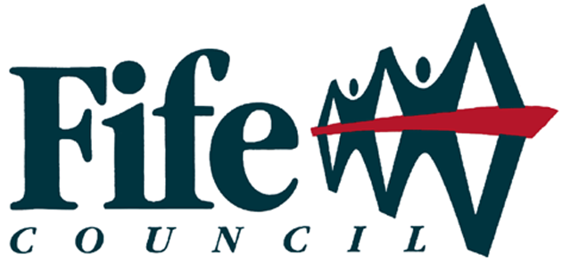

Fife Job Contract
Funding to support Unemployed Youths and Adults

Background

The Fife Job Contract (FJC) - Funding and supporting Unemployed Youths and Adults is the Fife Council response to high levels of unemployment. We are seeking to deliver support to help this group gain and sustain employment. Working with employers and Opportunities Fife Partners we are looking to create additional opportunities, particularly those who otherwise would not achieve a positive destination.

Funding £2Million
Timescale Nov 2014 to March 2017

Criteria

- Clients must be unemployed or at risk of not achieving a positive destination and not on the DWP Work Programme.
- Jobs should be additional.
- Jobs should be sustainable following funded period.
- Funding will be reimbursed at upto £NMW/hr per typical 36 hr week.
- All employers requesting funding must complete and submit a FJC Business Case Template for approval prior to any appointment.
- Clients must have an action/sustainability plan to support gaining and sustaining employment.

The Model

- Apprenticeships at level 3 are typically fully funded for upto 26 weeks
- Non Apprenticeship route ways and lower Level apprentices are typically funded upto 50% for 26 weeks
- Academy routes can be funded for an agreed period of time to prepare individuals to enter known apprenticeships and jobs aimed at those who may be facing barriers to employment.
- For all the above we can deliver pre recruitment training to support clients with interview skills and assessments to meet employer criteria and requirements.

Support

- Clients are supported throughout the recruitment and employment period by project support staff that can assist with action and sustainability planning.
- Employers signposted to appropriate training and employability providers.
- Help provided to identify training and development opportunities.
- Help is provided to employers to develop business case and to identify funding.
- Employers are provided with named contact to deal with queries and any issues arising.
- All vacancies posted on the Opportunities Fife Web Site and signposted to partners. Including assistance with sifting, interviews/selection and eligibility checks.

Contacting Us

Initial enquiries to:-  Grant Leaburn (FYJC Programme Manager)  Lead Officer - Employability & Skills  3rd Floor  Kingdom House  Kingdom Avenue  Glenrothes  KY7 5LY  Internal: 406723 (through VOIP)  External: 03451 55 55 55  + Ext 406723 (Direct Line)  Mobile: 07985 255 168  Fax: 01383 602542  E-Mail Grant.Leaburn@fife.gov.uk | All Business Case (Templates) to:-  Ann Salt  Employability Compliance Officer  Economy Planning & Employability Services  Skills Development Centre  Midfield Road  Mitchelston Industrial Estate  KIRKCALDY  KY1 3NL  Internal: 406729 (through VOIP)  External: 03451 55 55 55 + Ext 406729 (Line)  E-Mail: Ann.Salt@fife.gov.uk

 Like us at fifeyouthjobs  Follow us on Twitter @fifeyouthjobs
Or log on to www.opportunitiesfife.org for more information

